**Dynamic UI Framework**

Contents:

1. Introduction

1.1 About This Document

1.1.1 Scope of this document

1. Component Design

2.1 Component design diagram

2.1.1 Overall Workflow

2.1.2 Low Level Design

1. Technology & Frameworks Used
2. Solution Approach

1. Introduction

1.1 About this document

1.1.1 Scope & Purpose of this document

A Dynamic UI is a user interface that can adapt according to user input. A framework is the basic structure underlying a system. This Dynamic UI Framework will focus on creating a hassle-free interface for the user and will store most of the html data in a JSON format in the client machine in order to reduce time and ultimately, improve user experience. The purpose of this document is to provide a blueprint for developers who want to create a reusable component for a user interface that can be integrated into any application of the same tech stack.

2. Component Design

Component Design Diagram

Dynamic UI Framework

Simple Search, Grid

Generic Popup

Consumer

This is an implementation of a sample template featuring a Dynamic UI where the client will interact with the UI while being able to change/view information available by making use of their configuration file.

2.1.1 Overall Workflow

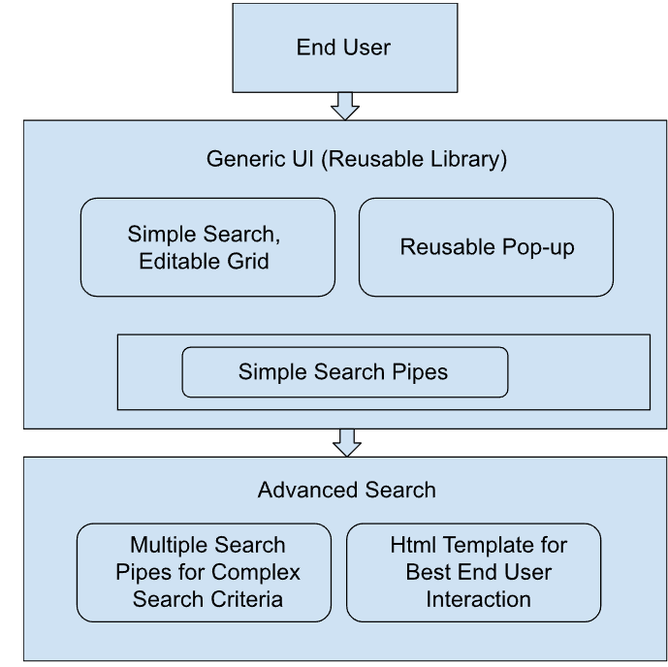

2.1.2 Low level Design

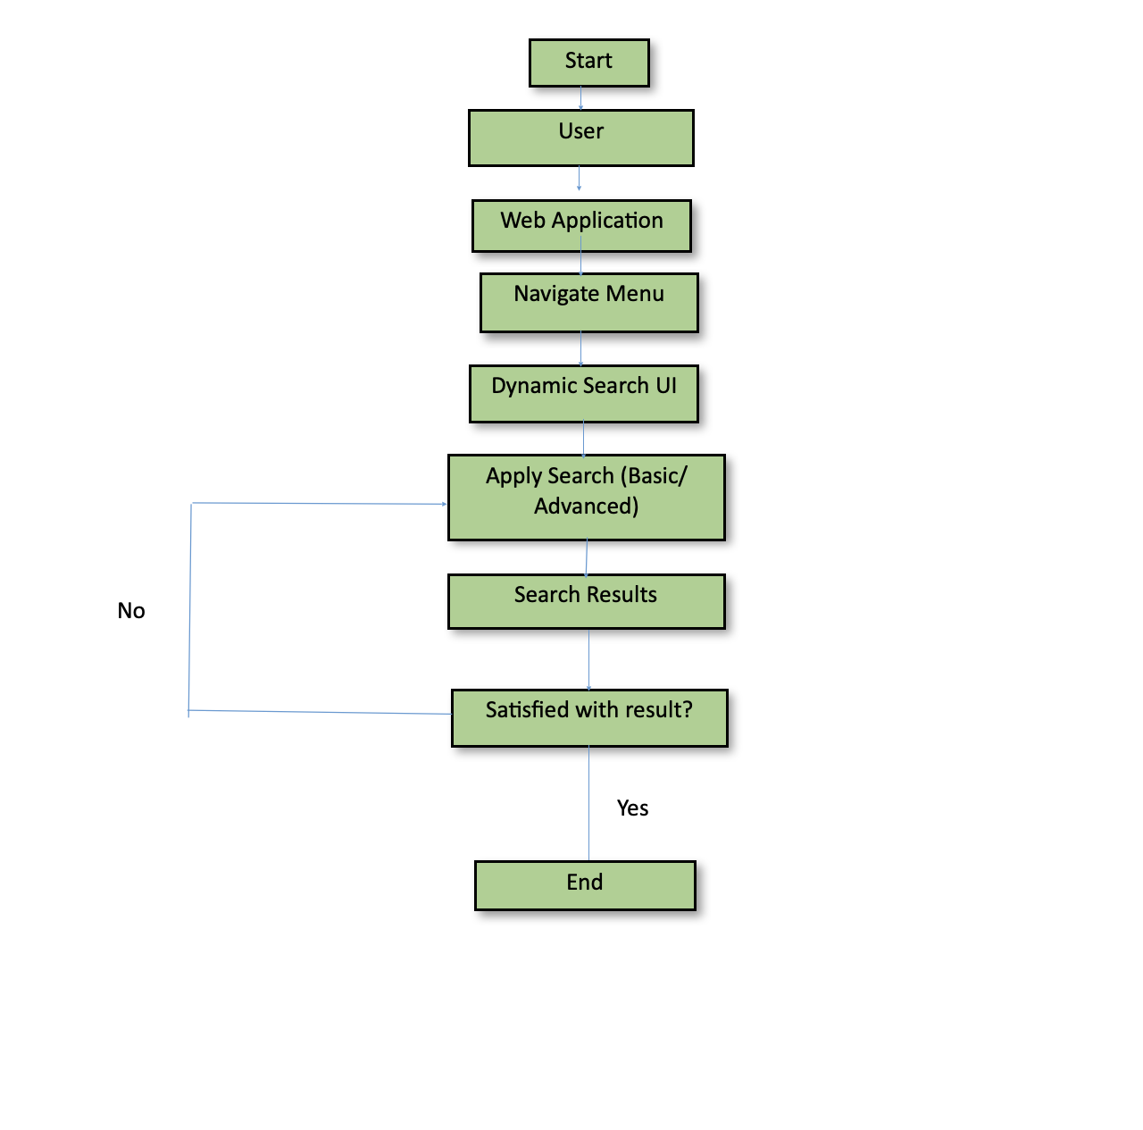

3 Technology & Frameworks used  
This below lists down the details on technology and framework used for development of the UI.

* 1. Angular 15.2.4
  2. Node 19.7.0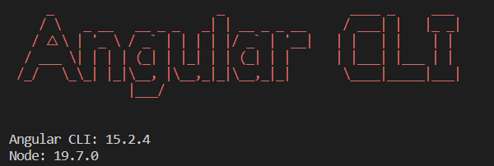

4 Solution Approach

This is a description of how we see clients using our framework.

We have multiple libraries that can be reused for many Use-Cases.

These include:

* Grid Library
* Generic Pop-Up Library
* Logger Library
* Simple Search which is present in Grid Library